Recent work includes a significant editorial and technical edit/rewrite role for three books published by WildGuides/Princeton University Press:

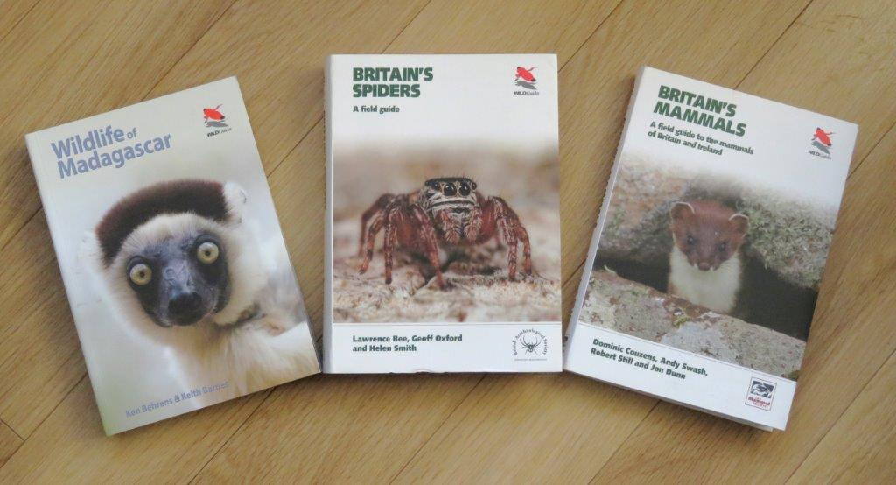

And a five-page spread in a recent issue of Conservation Land Management (full details given in the lists below):

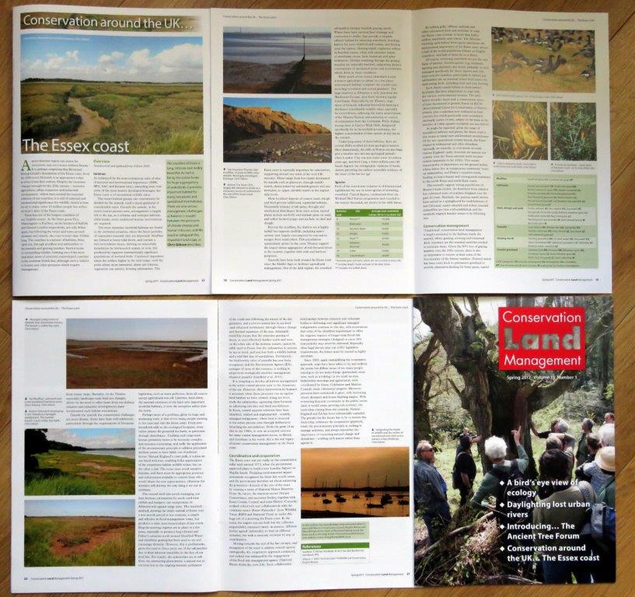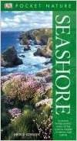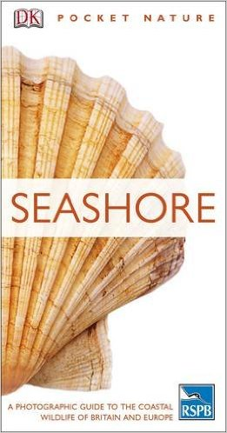

**GIBSON, C. (2008, 2011) *Pocket Nature: Seashore*. Dorling Kindersley.**

**Amazon Customer Reviews (7) : 4.7 out of 5 stars**

Selected comments:

‘A very precise handbook small enough to take out with you and with a waterproof cover also useful. I have also recommended this book to friends like myself who share this hobby. Very satisfying explanations and details’

‘This is an excellent book for reference purposes. A little large to carry around in the pocket but fine in a rucksack. It covers all those everyday questions when our and about.’

‘I bought this on impulse for my Granddaughter for when she started her marine biology course at university - when she saw it I could tell she wasn't impressed as she thought it was just for kids, but that soon changed when she was told it was the must have book for their first field trip, lots of good information in it and not overly complicated - she was more impressed as she got brownie points when she said she already had it.’

‘…this book stands out from others in being really jam-packed with beautifully detailed photos of the plants and animals’

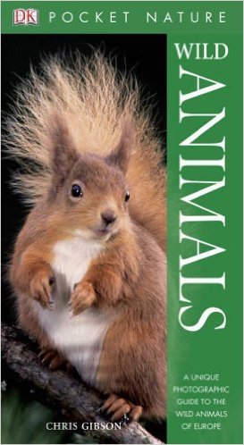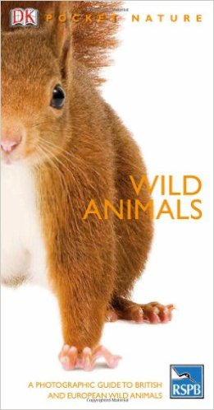

**GIBSON, C. (2005, 2010) *Pocket Nature: Wild Animals*. Dorling Kindersley, pp224. (plus French x 2, German and Polish editions)**

**Amazon Customer Reviews (6) : 4.3 out of 5 stars**

Selected Comments:

‘Another excellent book by DK Books. Fully detailed and illustrated. An enormous amount of information packed into a pocket-sized book. I fully recommend it to nature lovers.’

‘Brilliant book full of useful information about our wildlife.’

‘One of the problems of looking at wildlife abroad is the number of reference books you could take. This immediately reduces the load: no longer do you need heavy guides to reptiles, amphibians and mammals as it's all in here. The book is compact and accurate; what more can you ask for? It's packed with good photos and pithy notes.’

**Both of the above subsequently appeared under a DK/RSPB imprint. ‘Thanks very much RSPB’: I got no money for that, and they removed my name from the front cover…**

GIBSON, C. (contributing author) (2010) *Chris Packham’s Nature Handboo*k. Dorling Kindersley/RSPB, pp255

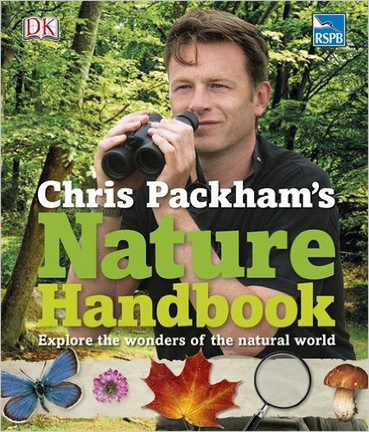

GIBSON, C. (contributing author) (2010) *The Natural History Book: the ultimate visual guide to everything on earth*. Dorling Kindersley, pp648.

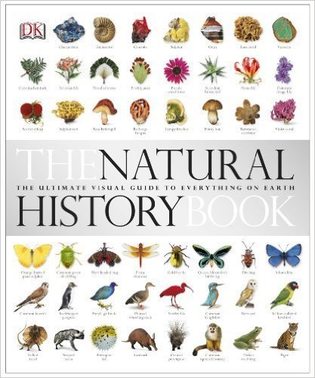

GIBSON, C. (contributing author) (2009) *Where to go Wild in Britain*. Dorling Kindersley/RSPB, pp336.

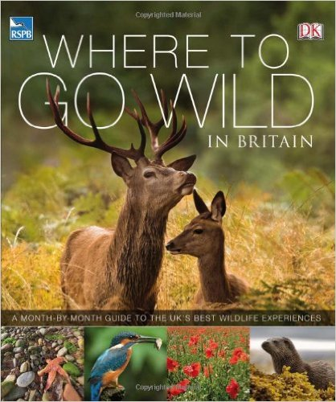

GIBSON, C. (contributing author) (2009) *Pocket Nature: Wildlife of Britain*. Dorling Kindersley/RSPB. pp600.

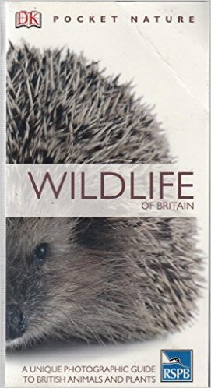

GIBSON, C. (contributing author) (2008) *Wildlife of Britain – the definitive visual guide*. Dorling Kindersley/RSPB. pp512.

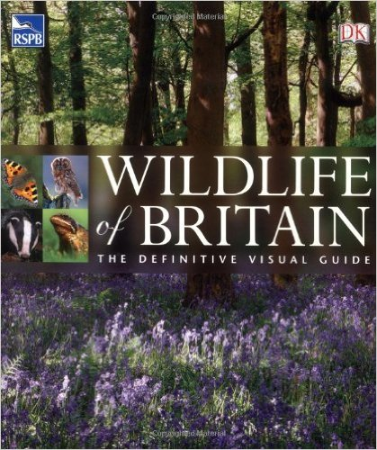

**Other books, booklets and chapters**

GIBSON, C. (2015) Foreword, pp ii-iii. In EAGLE, B. *Pushed to the Edge: a history of The Naze and Walton Hall.* pp 252 (at <https://completelynovel.com/books/pushed-to-the-edge-a-history-of-the-naze-and-walton-hall/read>)

GIBSON, C. (2007) Wetland Bird Survey in Essex. pp20-49 in WOOD, S. *The Birds of Essex*, Helm.

GIBSON, C. (2005) *Canvey Wick – a space for wildlife and people*. English Nature, pp8.

GIBSON, C. (2005) Foreword, in FORSYTH, L. *Island of wildlife: the story of Fingringhoe Wick.* Essex Wildlife Trust.

GIBSON, C. (2004) Recent population trends: the view from my garden. pp 17-32, in GOODEY, B (2004) *The Moths of Essex*. Lopinga Books.

GIBSON, C (2003) *The Essex Coast – its wildlife and conservation*. English Nature, 32pp.

GIBSON, C. (2000). *The Essex Coast . . . beyond 2000*. English Nature, Colchester, 40pp.

British Red Data Books 1: Vascular Plants, 3rd Edition (1999). Species accounts of *Filago lutescens*, *Limonium binervosum* (with S. Leach), *Peucedanum officinale*, *Rhinanthus angustifolius*

GIBSON, C. (1993) *Wildlife & Conservation of the Essex Coast.*  English Nature, 20pp.

GIBSON, C. (1990) Portugal. pp213-233, in *Mediterranean Wildlife, the Rough Guide,*  ed. RAINE. P. Harrap-Columbus, London.

GIBSON, C. (1990) *The Essex Coast*. Nature Conservancy Council, 12pp.

**Peer-reviewed scientific papers**

GIBSON, C. (2017) The Essex coast. *Conservation Land Management* **15** (1) **Spring 2017**, 17-21.

GIBSON, C. (2016) At your service? The limits of enterprise with nature at stake. *ECOS* **34**, 21-23.

ROSS-SMITH, V., ROBINSON, R., BANKS, A., FRAYLING, T., GIBSON, C. & CLARK, J. (2014) The Lesser Black-backed Gull *Larus fuscus* in England: how to resolve a conservation conundrum. *Seabird* **27**: 41–61.

ADAM BATES, JON SADLER, DAVE GRUNDY, NORMAN LOWE, GEORGE DAVIS, DAVID BAKER, MALCOLM BRIDGE, ROGER FREESTONE, DAVID GARDNER, CHRIS GIBSON, ROBIN HEMMING, STEPHEN HOWARTH, STEVE ORRIDGE, MARK SHAW, TOM TAMS & HEATHER YOUNG (2014) Garden and landscape –scale correlates of moths of differing conservation status: Significant effects of urbanization and habitat diversity. *PLOS ONE* **9 (1)** e86925: 1-11.

ADAM J. BATES, JON P. SADLER, GLYN EVERETT, DAVE GRUNDY, NORMAN LOWE, GEORGE DAVIS, DAVID BAKER, MALCOLM BRIDGE, JON CLIFTON, ROGER FREESTONE, DAVID GARDNER, CHRIS GIBSON, ROBIN HEMMING, STEPHEN HOWARTH, STEVE ORRIDGE, MARK SHAW, TOM TAMS & HEATHER YOUNG (2013) Assessing the value of the Garden Moth Scheme citizen science dataset: how does light trap type affect catch? *Entomologia Experimentalis et Applicata* **146**: 386–397.

MORRIS, R.K.A. & GIBSON, C. (2007) Port development and nature conservation – experiences in England between 1994 and 2005. *Ocean & Coastal Management* **50:** 443-462.

GIBSON, C. & GIBSON, M. (2007) Halo phenomenon over Dovercourt. *Essex Naturalist (New Series)* **24:** 43-44.

GIBSON, C. (2006) Climate change and north-east Essex. *Nature in North-east Essex 2006*: 91-95.

GIBSON, C. (2006) Wildlife & conservation review of 2005. *Essex Naturalist (New Series)* **23**: 18-30.

GIBSON, C. (2006) Some like it hot…: adaptation strategies. *Suffolk Natural History* **42**: 19-23.

GIBSON, C. (2004) Wildlife and conservation review of 2003. *Essex Naturalist (New Series)* **21**: 27-41.

RINGWOOD, Z., HILL, J. & GIBSON, C. (2004) Conservation management of *Gortyna borelii lunata* (Lepidoptera: Noctuidae) in the United Kingdom. *Journal of Insect Conservation* **8**: 173-183.

GIBSON, C. (2003) Wildlife & conservation review of 2002. *Essex Naturalist (New Series)* **20**: 19-36.

RINGWOOD, Z.K., HILL, J. & GIBSON, C. (2002) Observations on the ovipositing strategy of *Gortyna borelii* Pierret, 1837 (Lepidoptera, Noctuidae) in a British population. *Acta Zoologica Academiae Scientiarum Hungaricae* **48**(2): 89-99.

GIBSON, C. (2002) Wildlife and conservation review of 2001. *Essex Naturalist (New Series)* **19:** 43-62.

GIBSON, C. (2001) Wildlife & conservation review of 2000. *Essex Naturalist* *(New Series)* **18**: 38-53.

GIBSON, C. (2000). Profile of a naturalist: Geoffrey Arthur Pyman MBE (1920-1999). *Essex Naturalist (New series)* **17**: 16-20.

GIBSON, C. (2000). Wildlife and conservation review of 1999. *Essex Naturalist (New series)* **17**: 38-49.

GIBSON, C. (2000). Notes on Essex specialities. 3. Annual Sea-purslane *Atriplex pedunculata*. *Essex Naturalist (New series)*, **17**: 129-132.

GIBSON, C. (2000). The conservation of *Gortyna borelii lunata* Freyer (Lep: Noctuidae). *Entomologist’s Record* **112:** 1-5.

RINGWOOD, Z., HILL, J. & GIBSON, C. (2000) A study of *Gortyna borelii lunata* Freyer (Lep.: Noctuidae): results from the first season of behavioural observation sessions. *Entomologist’s Record* **112:** 93-99.

GIBSON, C. (1999) Wildlife and conservation review of 1998. *Essex Naturalist (New Series)* **16**: 19-24.

GIBSON, C, (1999) *Celypha arbutella* (Lepidoptera: Tortricidae) - a new micromoth for Essex (and England?). *Essex Naturalist (New Series)* **16:** 31.

RICH, T.C.G., GIBSON, C. & MARSDEN, M. (1999) Re-establishment of the extinct native plant *Filago gallica* L. (Asteraceae), narrow-leaved cudweed, in Britain. *Biological Conservation* **91:** 1-8.

GIBSON, C. (1998) New protection for Fisher’s Estuarine Moth. *Essex Naturalist (New Series)* **15**: 22.

GIBSON, C. (1997) Conservation in Essex: a view from English Nature. *Essex Naturalist (New Series)* **14**: 143-153.

GIBSON, C. & WATKINSON, A.R. (1992) The role of the hemiparasite annual *Rhinanthus minor* in determining grassland community structure. *Oecologia* **89**: 62-68.

GIBSON, C. & WATKINSON, A.R. (1991) Host selectivity and the mediation of competition by the root hemiparasite *Rhinanthus minor*. *Oecologia* **86**: 81-87.

GIBSON, C. & WATKINSON, A.R. (1989) The host range and selectivity of a parasitic plant: *Rhinanthus minor* L. *Oecologia* **75:** 401-6.

WATKINSON, A.R. & GIBSON, C. (1988) Plant parasitism: the population dynamics of parasitic plants and their effects on plant community structure. pp393-411 in *Plant* *Population Ecology*, eds. DAVY, A.J., HUTCHINGS, M.J., WATKINSON, A.R. Blackwell.

WATKINSON, A.R. & GIBSON, C. (1985) Life-history variation and the demography

of plant populations, pp105-113 in *Structure & Functioning of Plant Populations 2:*

*Phenotypic and Genotypic Variation in Plant Populations,* eds. HAECK, J. &

WOLDENDORP, J.W. North Holland.

**Other less formal articles and notes**

GIBSON, C. (2010) An alternative view from my moth trap: the by-catch. *Nature in North-east Essex 2010*: 44-54.

GIBSON, C. (2007) What decline of the caddisfly? *Atropos* **32**: 39-40.

SUTHERLAND, W. & GIBSON, C. (1988) Habitats to order. *New Scientist*, 28/1/2008: 70.

GIBSON, C. (2001) Olive Crescent *Trisateles emortualis* larvae in Essex. *Atropos* **12**: 81.

RICH, T., GIBSON, C. & MARSDEN, M. (1996) *Narrow-leaved cudweed (*Filago gallica*) report for 1996*. Plantlife project report 75.

RICH, T., GIBSON, C. & MARSDEN, M. (1995) *Narrow-leaved cudweed (*Filago gallica*) is back from the brink…* Plantlife project report 67.

GIBSON, C. (1992) Jackdaws feeding on horse-chestnuts. *British Birds* **85**(3): 138.

GIBSON, C. (1992) Wildlife and conservation in north-east Essex. pp18-22 in *Lepidoptera of North-east Essex*, GOODEY, B. & FIRMIN, J. *Nature in North-east Essex* Special Edition 1992.

GIBSON, C. (1987, 1989). *A Natural History of the UEA Campus* (with first supplement). pp 218 + 39.

GIBSON, C. (1987) Parasitic plants as gall-causers. *Cecidology* **2**: 41-43.

GIBSON, C. (1986) Turnstones feeding on cliff ledges. *British Birds* **79**(8): 402.

**Other significant published uses of my photos**

ALLISON, K. (2011) *A Guide to Plants Poisonous to Horses (Revised Edition)*. J.A. Allen.

CHATTERS, C. (2009) *Flowers of the Forest: plants and people in the New Forest National Park*. Wildguides.

GUNTON, T. (2008) *Explore Wild Essex: a guide to nature reserves and country parks of Essex and east London*. Lopinga.

PORLEY, R. (2008) *Arable Bryophytes*. Wildguides.

WOOD, S. (2007) *The Birds of Essex*, Helm.

FLETCHER, N. (2007) *Pocket Nature: Mediterranean Wild Flowers*. Dorling Kindersley.

ENGLISH NATURE (2005) *The East of England’s Best Wildlife and Geological Sites*.

LANG, D. (2005) *Britain’s Orchids*. Wildguides.

PRICE, M. & WALSH, K. (2005) *Pocket Nature: Rocks and Minerals.* Dorling Kindersley.

ROYAL HASKONING (2005) *Saltmarsh Management Manual.*  Defra / Environment Agency.

ENGLISH NATURE (2005) *Our Coast & Seas: making space for people, industry and wildlife.*

McGAVIN, G. (2004) *Pocket Nature: Insects and spiders*. Dorling Kindersley.

STERRY, P. & MACKAY, A. (2004) *Pocket Nature: Butterflies and Moths*. Dorling Kindersley.

COOMBES, A. (2004) *Pocket Nature: Trees*. Dorling Kindersley.

FLETCHER, N. (2004) *Pocket Nature: Wild Flowers*. Dorling Kindersley.

STACE, C.A., van der MEIJDEN, R. & de KORT, I. (2004) *Interactive Flora of the British Isles*. ETI DVD-ROM.

DEFRA (2004) *Code of Practice on how to Prevent the Spread of Ragwort*. <https://www.gov.uk/government/uploads/system/uploads/attachment_data/file/69264/pb9840-cop-ragwort.pdf>

GOODEY, B (2004) *The Moths of Essex***.** Lopinga.

WILSON, P. & KING, M. (2003) *Arable Plants - a field guide*. Wildguides.

ENGLISH NATURE (2003) / NATURAL ENGLAND (2007) *Gardening with wildlife in mind*. CD-ROM

MOD (2001) Photographic competition winners 2001. *Sanctuary* **30.**

ENGLISH NATURE (2001) *Practical Solutions Handbook*, Edition 2.

GUNTON, T. (2000) *Wild Essex: a guide to nature reserves and country parks of Essex and east London*. Lopinga.

Also see

HONEYGUIDE website [www.honeyguide.co.uk](http://www.honeyguide.co.uk)

DTA Publications [www.dtapublications.co.uk](http://www.dtapublications.co.uk)

**Other books and publications with significant editorial input**

COUZENS, D., SWASH, A., STILL, R. & DUNN, J. (2017) *Britain’s Mammals: A field guide to the mammals of Britain and Ireland.* WildGuides/Princeton University Press, pp328.

BEE, L., OXFORD, G. & SMITH, H. (2017) *Britain’s Spiders: A field guide*. WildGuides/Princeton University Press, pp480.

BEHRENS, K & BARNES, K. (2016) *Wildlife of Madagascar*. WildGuides/Princeton University Press, pp344.

ALLISON, K. (2011) *A Guide to Plants Poisonous to Horses (Revised Edition)*. J.A. Allen.

CHATTERS, C. (2009) *Flowers of the Forest: plants and people in the New Forest National Park*. Wildguides.

DORLING KINDERSLEY (2009) *Where to go Wild in Britain*. Dorling Kindersley/RSPB, pp336.

DORLING KINDERSLEY (2008) *Wildlife of Britain – the definitive visual guide*. Dorling Kindersley/RSPB. pp512.

GUNTON, T. (2008) *Explore Wild Essex: a guide to nature reserves and country parks of Essex and east London*. Lopinga.

BENTON, T. & DOBSON, J. (2007) *The Dragonflies of Essex*. Lopinga

BENTON, T. (2006) *Bumblebees*. Collins New Naturalist.

FORSYTH, L. (2005) *Island of wildlife: the story of Fingringhoe Wick.* Essex Wildlife Trust.

STERRY, P. & MACKAY, A. (2004) *Pocket Nature: Butterflies and Moths*. Dorling Kindersley.

COOMBES, A. (2004) *Pocket Nature: Trees*. Dorling Kindersley.

FLETCHER, N. (2004) *Pocket Nature: Wild Flowers*. Dorling Kindersley.

GOODEY, B (2004) *The Moths of Essex*. Lopinga

WILSON, P. & KING, M. (2003) *Arable Plants - a field guide*. Wildguides.

ENGLISH NATURE (2003) / NATURAL ENGLAND (2007) *Gardening with wildlife in mind*. CD-ROM.

PRESTON, C., PEARMAN, D. & DINES, T. (2002) *New Atlas of the British & Irish Flora.* OUP.

BENTON, T. (2000) *The Bumblebees of Essex*. Lopinga.

GUNTON, T. (2000) *Wild Essex: a guide to nature reserves and country parks of Essex and east London*. Lopinga.

CROOKES, J. (1999) *Watching over Essex 1959-1999.* Essex Wildlife Trust.

DOBSON, J. (1999) *The Mammals of Essex.* Lopinga.

ESSEX BIODIVERSITY PARTNERSHIP (1999) *Essex Biodiversity Action Plan – a wild future for Essex?*

TARPEY, T & HEATH, J. (1990) *Wild flowers of North-east Essex*. CNHS.

English Nature’s *Patchwork* **1** (1996) - **11** (2003).

*Essex Naturalist* *(New Series)* **16**(1999) to date.

**An unabridged version of this document is available!**