Chattowood 2025: report by Dr Chris Gibson

Monitoring of the Chattowood front gardens was continued for a fourth summer in 2025. Only those gardens which were originally planted in in April 2022 were included in the comparison ie those which have additionally been planted since then and were thus less mature were not surveyed.
Methodology was exactly the same as previous years (see appendix), at approximately monthly intervals throughout the summer.

All macroinvertebrates (larger than ladybird size) were recorded, and assigned at least to main group. It is not a biodiversity comparison as such given that few were assigned to species level; it is however a bioabundance comparison.

High-level comparison between the years:

The results tabulated below indicate consistent imbalance between the Chatto-style gardens and the adjacent traditional front gardens. It would appear that there are typically ten times as many macroinvertebrates (mostly pollinators) on our side of the divide. It may be best to exclude the data from 2022 which indicated an even greater imbalance as surveys were undertaken that year only after midsummer.

The broad data also show clearly how much better 2025 was than either of the two previous years, on both sides of the divide. On the Chatto side, there were some 75% more while on the other side of the great divide there were around 50% more (although it must be recognised that sampling effort was not exactly consistent between years).

year | surveys | Total # insects BC-side | Total # other side | Ratio BC:other
2022 | 6 (19 Aug-22 Sept) | 120 | 6 | 20:1
2023 | 6 (17 Apr – 4 Sept) | 233 | 28 | 8.3:1
2024 | 7 (7 Apr - 17 Sept) | 240 | 25 | 9.6:1
2025 | 6 (24 Apr – 19 Sep) | 426 | 39 | 10.9:1

As the monitoring has progressed, it has been noticeable that the number of actively ground-nesting insects has increased in the older Chattowood plantings, I suspect as a crust has developed on the surface of the sand, so the holes don’t collapse. Three species at least have colonized from 2024 onwards: Bee-wolf Philanthus triangulum, Ivy Bee Colletes hederae and Sand Wasp Ammophila sabulosa. In 2025, the nests of Ivy Bees were certainly more numerous and widespread than those in 2024.

Each year’s more detailed data are available but below is presented the monthly data from 2025.
Date | 26/4 | 29/5 | 20/6 | 18/07 | 20/08 | 19/09
Weather | Sunny, chill breeze, 14deg | Sunny, breezy, warm 20deg | Sunny, hot, gentle breeze, 26deg | Sunny, hot, 27deg | Light cloud, warm, breezy 19dec | Sunny, very warm, light winds 25 deg
CHATTOWOOD
Bumblebee incl carder bee | 3 | 22 | 11 | 106 | 28 | 5
Honeybee | 2 | 30 | 53 | 12 | 4 | 3
Solitary bee | 3 | 1 | 14 | 1
Leaf-cutter bee |  |  | 1
Ivy Bee |  |  |  |  |  | 42
Social wasp |  |  |  | 1 | 3
Sand Wasp |  |  |  |  | 1
Bee Wolf |  |  |  |  | 1
Other solitary wasp |  |  |  |  |  | 2
Hoverfly | 3 |  | 7 |  |  | 1
Other larger fly | 2 | 1 | 13 |  | 1 | 1
Rosemary Beetle |  |  | 10 |  | 2 | 9
Ladybird |  |  | 1 |  | 1 | 8
Rove-beetle |  |  |  |  |  | 1
Strawberry Seed-beetle |  |  |  |  |  | 1
Hogweed Bonking-beetle |  |  |  | 1
Red Admiral butterfly |  |  |  | 3 |  | 1
Painted Lady butterfly |  |  |  |  |  | 1
Peacock butterfly |  |  |  |  |  | 2
Common Blue butterfly |  | 1 |  |  |  | 1
Large White butterfly |  |  |  | 3
Gatekeeper butterfly |  |  |  |  | 1
Mint Moth |  | 2 | 1
Hummingbird Hawkmoth |  |  |  |  |  | 1
Common Blue Damselfly |  |  | 2
Cinnamon Bug |  |  |  |  | 1 | 1
Hairy Shield-bug |  |  |  |  |  | 2
Garden Cross Spider |  |  |  |  |  | 1
TOTAL | 13 | 57 | 113 | 127 | 43 | 83
CUMULATIVE TOTAL | 13 | 60 | 173 | 300 | 343 | 426
ADJACENT DEVELOPMENT
Bumblebee |  | 1 | 2 | 1 | 1 | 2
Honeybee |  | 2 | 4
Sand Wasp |  |  |  |  | 1
Hoverfly |  |  | 3
Cranefly | 1 |  |  |  |  | 1
Other larger fly | 4 | 1 |  | 1 |  | 1
Rosemary beetle |  |  | 3
Ladybird | 1 |  |  |  |  | 2
Light Brown Apple Moth |  |  | 1
Cinnabar Moth |  |  | 1
Agriphila geniculea micromoth |  |  |  |  |  | 1
Green Shield-bug |  |  |  |  |  | 1
Common Field Grasshopper |  |  | 1 | 1 | 1
TOTAL | 6 | 4 | 15 | 3 | 3 | 8
CUMULATIVE TOTAL | 6 | 10 | 25 | 28 | 31 | 39

Notes were kept of the species of plant attracting most insect activity. This shifted on a monthly basis; over the other side, the plants attracting the (much lower) numbers of insects were composites (Bellis, Taraxacum, Hypochaeris, Scorzoneroides) and Malva (all lawn ‘weeds’ and only when not recently mown) plus Lavandula and Escallonia planted in some front gardens.
- April – Ceanothus, Geranium, Thymus and Cistus most attractive; Bellis/Taraxacum on the other side
- May – Cistus, Genista, Cytisus, Nepeta; other side Hypochaeris
- June – Santolina, Lavandula; other side Malva, Lavandula
- July – Budddleia, Salvia, Lavandula
- Aug – Buddleja, Salvia, Lavandula; other side Scorzoneroides autumnalis
- Sep – Buddleja, Salvia, Lavandula; other side Scorzoneroides autumnalis, Escallonia

Dr Chris Gibson, Beth Chatto Gardens’ Wildlife Advocate
chrismothman@btinternet.com
www.chrisgibsonwildlife.co,uk
02 November 2025

Appendix: Previous reports
2024 report

Monitoring of the Chattowood front gardens was continued for a third summer in 2024. Only those gardens which were originally planted in in April 2022 were included in the comparison ie those which have additionally been planted since then and were thus less mature were not surveyed.
Methodology was exactly the same as previous years, at approximately monthly intervals throughout the summer.

The results tabulated below indicate a similar picture to previous years, except that the imbalance between the Chatto-style gardens and the adjacent traditional front gardens was less marked in both 2023 and 2024.

High-level comparison between the years:
year | surveys | Total # insects BC-side | Total # other side | Ratio BC:other
2022 | 6 (19 Aug-22 Sept) | 120 | 6 | 20:1
2023 | 6 (17 Apr – 4 Sept) | 233 | 28 | 8.3:1
2024 | 7 (7 Apr - 17 Sept) | 240 | 25 | 9.6:1

I would suggest that this reduced differential is due to two factors:

- For reasons perhaps related to spring/summer weather (dull, damp, often breezy) and the lack of frosts in the previous winters, the early months of summer 2023 and most of summer 2024 (until September) were notoriously poor for insects everywhere. It is very difficult to demonstrate differences in value to insects when there are simply almost no insects to record: the very few found next door assumed a magnified importance in relative terms.
- Since 2022, some of the front gardens in the adjacent comparison site have had a degree of positive planting, with for example Lavandula and Escallonia in a couple of them. Those plants (plus the occasional lawn ‘weed’) were responsible for attracting most of the insects next door.

I therefore have no concerns that the Chatto-style planting is having reduced attractivity to insects and that this in anyway invalidates our faith in this approach to gardening in new estates. Indeed, I would expect the gap to close still further (subject to vagaries of the weather) as the ‘adjacent gardens’ continue to be gradually diversified.
It is also interesting to note the arrival of ground-nesting insects in the older Chattowood sand gardens, I suspect as a crust has developed on the surface, so the holes don’t collapse. Three species at least have colonized this summer, Bee-wolf Philanthus triangulum, Ivy Bee Colletes hederae and Sand Wasp Ammophila sabulosa. The first two are not too surprising given that they have undergone significant spread from southern regions in recent decades due to climate change, but the Sand Wasp has always been here, just restricted to heathlands. It is common on the Suffolk coast, and also around Tiptree/Layer Breton and Fingringhoe Wick, but I have never seen it closer (Cockaynes Reserve would be a good candidate). Clearly, these creatures must be moving around our landscape searching for spots they can thrive.

Cathy Butcher also reported finding earthworm casts on the pure sand in autumn, and fungi growing out of it. Both are significant, indicating that organic matter is collecting in the upper layers (perhaps related to the crust that allows bees and wasps to nest). The bare sand is developing an ecology: what lies beneath the surface is adding complexity and life.
I also used the final survey of the year as one of the sessions mentoring Rob Byford, particularly to introduce him to the ‘quick and dirty’ survey protocols often associated with citizen science projects.

Date | 7 Apr AM | 28 May AM | 20 June PM | 15 July AM | 5 Aug AM | 16 Aug PM | 17 Sept AM
Weather | bright 18° | Breezybright, cool 18° | Hot and sunny  22° | Hazy sunshine, calm 20° | Sun, light cloud, humid 23° | Sunny, still  23° | Sunny, lightish wind 19°
CHATTOWOOD
Bumblebee (incl Carder) | 9 | 4 | 1 |  | 32 | 50 | 17
Honeybee | 6 | 1 | 2 | 4 | 9 | 2 | 4
Solitary bee |  |  |  |  | 1
Ivy Bee |  |  |  |  |  |  | 25
Hoverfly | 1 | 3 | 1 | 3 | 2 | 1
Social wasp |  |  |  |  | 1 |  | 1
Bee-wolf |  |  |  | 1 | 1
Sand Wasp |  |  |  |  | 1
Digger wasp sp |  |  |  |  |  |  | 2
Crane fly | 1 |  |  |  |  |  | 1
Other fly | 7 | 3 | 1 | 2 | 3 | 1 | 3
Rosemary Beetle |  | 1 |  |  |  |  | 2
Ladybird |  |  |  | 1 | 1 | 1
Small White butterfly |  |  |  |  |  |  | 13
Large White butterfly |  |  |  |  |  |  | 4
Red Admiral butterfly |  |  |  |  |  | 1
Painted Lady butterfly |  |  |  | 1 |  | 1
Mint Moth | 2 |  | 1 |  | 2 | 1 | 1
TOTAL | 26 | 12 | 6 | 12 | 53 | 58 | 73
CUMULATIVE TOTAL | 26 | 38 | 44 | 56 | 109 | 167 | 240
ADJACENT DEVELOPMENT
Bumblebee |  |  |  |  | 1 |  | 5
Social wasp |  |  |  |  |  |  | 1
Honeybee |  |  |  | 2
Common Field Grasshopper |  |  |  |  |  | 1
Other fly | 2 | 1 |  |  | 2 |  | 2
Ladybird | 1
Red Admiral butterfly |  |  |  |  |  | 1
Large White butterfly |  |  |  |  |  |  | 1
Small White butterfly |  |  |  |  |  |  | 3
Grass Moth | 1 |  |  | 1
TOTAL | 4 | 1 | 0 | 3 | 3 | 2 | 12
CUMULATIVE TOTAL | 4 | 5 | 5 | 8 | 11 | 13 | 25

Notes:
- April – Ceanothus, Thymus and Cistus most attractive; Bellis on the other side
- May – very chilly and had been wet. Not good insect conditions. Lavandula best
- June – very low numbers throughout continued. The hot weather had been in place for less than 2 days. Nepeta and Lavandula best
- July - Still no bumblebees and few insects generally. In our bit, Senecio, Lavandula and Nepeta best; over the other side all insects were on Lavandula planted by owners
- Early August – bumblebees and honeybees now out in some force, but no butterflies at all. Lavandula and Salvia yangii best, visits also to Agapanthus, Gaura, Cynara. Bee-wolf nest. And surprise colonisation by Ammophila sabulosa. Next door, very few again, and all insects on Hypochaeris/Crepis lawn weeds
- Mid Aug Salvia, Ballota, Gaura best
- Sept – Gaura, Buddleia, Nepeta best– and Ivy Bee moved in in a big way as breeder, esp in first gardens either side of approach; next door, Escallonia and Leontodon lawn ‘weeds’ feeding some insects.

2023 Report
Monitoring of the Chattowood front gardens was continued for a second summer in 2023. Only those gardens which were originally planted in in April 2022 were included in the comparison ie those which have additionally been planted since then and were thus less mature were not surveyed.

Methodology was exactly the same as last year except that surveys were undertaken at approximately monthly intervals throughout the summer, rather than just in August and September.

The results tabulated below indicate a similar picture to 2022, except that the imbalance between the Chatto-style gardens and the adjacent traditional front gardens was less marked. There were 233 insects counted in our gardens compared with 28 adjacent, an eight-fold difference, compared with the twenty-fold difference in 2022. I would suggest that this reduced differential is due to two factors:

- the early months of summer 2023 were notoriously poor for insects everywhere, and it is very difficult to demonstrate differences in value to insects when there are simply almost no insects to record, and the very few found next door assumed a magnified importance in relative terms.
- Since 2022, some of the front gardens in the adjacent comparison site have had a degree of positive planting, with for example Lavandula and Escallonia in a couple of them. Those plants (plus the occasional lawn ‘weed’) were responsible for attracting most of the insects next door.

I therefore have no concerns that the Chatto-style planting is having reduced attractivity to insects and that this in anyway invalidates our faith in this approach to gardening in new estates. Indeed, I would expect the gap to close still further (subject to vagaries of the weather) as the ‘adjacent gardens’ continue to be gradually diversified.

Date | 17 Apr PM | 30 May AM | 16 Jun AM | 6 Jul PM | 15 Aug AM | 4 Sept AM
Weather | bright 14° | Light cloud, breezy 15° | Sunny 21° | Sunny 23° | Sunny 22° | Sunny, breezy 22°
CHATTOWOOD
Bumblebee | 1 | 4 | 48 | 46 | 25 | 16
Honeybee | 1 |  |  | 16 | 7 | 11
Hoverfly | 2 |  | 15 | 7 | 3 | 2
Other fly |  |  |  |  | 2 | 4
Rosemary Beetle |  |  | 2 |  |  | 2
Meadow Brown butterfly |  |  | 1
Small White butterfly |  |  |  |  | 1 | 1
Brown Argus butterfly |  |  |  |  | 1
Holly Blue butterfly |  |  |  |  |  | 1
Mint Moth |  |  |  |  | 2 | 2
Ladybird |  |  |  | 1 |  | 1
Social wasp |  |  |  |  | 2
Bee-wolf |  |  |  | 3
Common Blue Damselfly |  |  |  |  | 1
Digger wasp |  |  |  |  |  | 2
Cinnamon Bug |  |  |  |  |  | 1
TOTAL | 4 | 4 | 66 | 72 | 44 | 43
CUMULATIVE TOTAL | 4 | 8 | 74 | 146 | 190 | 233
ADJACENT DEVELOPMENT
Bumblebee |  |  | 4 | 3
Crane fly |  |  | 2
hoverfly | 1 |  | 5 | 3 |  | 1
Other fly |  |  |  |  | 1 | 1
Solitary bee |  |  | 2
Ladybird |  |  | 1 |  |  | 1
Holly Blue butterfly |  |  |  |  | 1
Honeybee |  |  |  |  |  | 1
Box Moth |  |  |  |  |  | 1
TOTAL | 1 | 0 | 14 | 6 | 2 | 5
CUMULATIVE TOTAL | 1 | 1 | 15 | 21 | 23 | 28

Notes:
- First two surveys during cool, dull, north-easterly dominated spring when there were few insects anywhere
- April survey – very little in flower apart from Bergenia
- Great to see House Martins colonising the gables of at least two of the houses over ‘our’ garden plots – obviously will benefit from rich supply of insects
- Also in June, difference between original April 2022 plots and more recent similar-style plantings very instructive and encouraging
- June survey – noticeable that most of the insects in the Adjacent Development (especially bumblebees) were feeding on ‘weed’ Poppies that have had the temerity to sprout through the mown grass turf…
- July survey, Lavandula and Teucrium attracting most interest on ‘our’ side; the other side, the few insects were all on Ragwort and Prckly Hawk’s-beard ‘weeds’ and on two planted lavenders
- August survey Salvia yangii and Gaura proving most attractive
- September survey – Salvia, Verbena and Lavandula the main attractors at Chattowood side; on other side , it was recently planted lavender and Escallonia

2022 Report
Chattowood: the first summer…
The new housing development of Chattowood lies in Elmstead Market, close to the Beth Chatto Gardens. Agreement was reached to plant parts of the estate with a ‘Beth Chatto-style right plant right place’ mix as a showpiece of sustainable gardening. Agreement was reached that the front gardens would remain as part of the estate fabric, and so not be subject to the management whims of future occupants of the adjacent houses.
The planting was undertaken in April 2022 into 30cm of locally-sourced sand placed directly on top of the subsoil, following removal and disposal of topsoil. The planting consisted of drought tolerant, insect-friendly plants which are a keystone for sustainable gardening in the face of climate collapse. The new plants were watered in but not subsequently. In this way the methodology was in keeping with Beth’s Gravel Garden.
I first visited on 29 June, when it looked magnificent. Clearly there would be value in surveying the insect use of these front gardens, and comparing and contrasting the findings with equivalent surveys on the ‘traditional’ new estate (turf, lollipop trees and low hedging) right next door. I agreed to undertake this comparison.
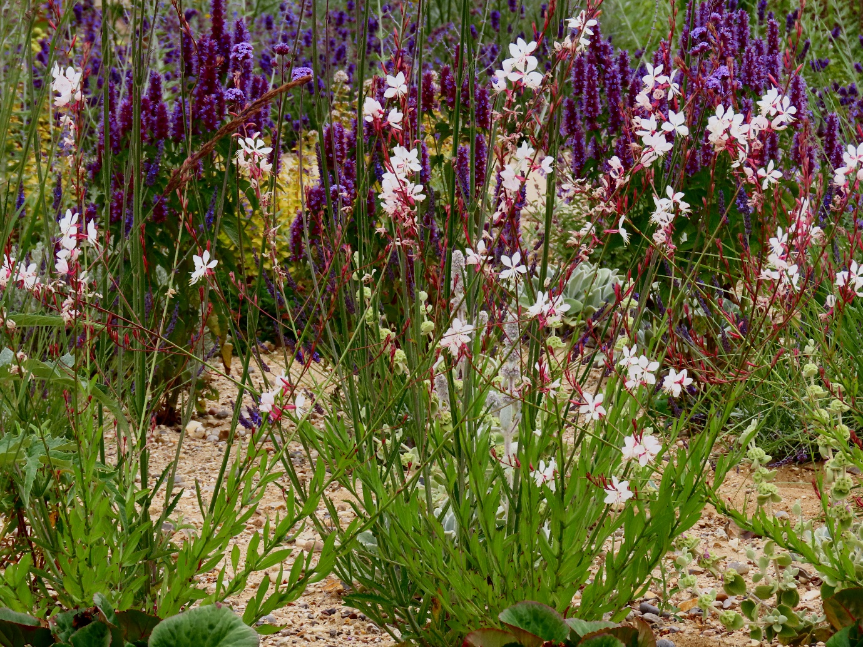
I opted for simple walk-past census of the gardens, which at a very slow pace took some 15-20 minutes. Any longer and the survey would have been more subject to the issues of double-counting. Insects were assigned to major groups; only those which are readily identifiable at a glance were identified down to species level. A similar length of time was spent surveying for insects in the front gardens and public areas of the adjacent estate immediately after each Chattowood survey.
It was intended that surveys would commence in July. However, due to circumstances outside my control (intense heat, which would have suppressed insect activity, followed by personal injury which left me immobile) it was not possible to start until mid-August.
During the three August surveys, it was apparent that there were rather fewer plants still flowering than one might have expected, a result of the record-breaking summer heat and intense drought. However, it was very pleasing to note that while flowering may have been curtailed, very few plants had died as a result of the extreme conditions.
A second series of counts were undertaken in September after the first heavy rains for several months. Given the later season, fewer insects were counted.
Results are tabulated below.

Date | 19 Aug AM | 22 Aug PM | 26 Aug AM | 12 Sep AM | 19 Sep AM | 22 Sept PM
Weather | Sunny 23° | Sunny 23° | Sunny 23° | Hazy sun 23° | Light cloud 15° | Hazy sun 17°
CHATTOWOOD
Bumblebee  (4 species) | 21 | 29 | 22 | 10 | 3 | 8
Honeybee |  |  | 1
social wasp |  |  | 1
hoverfly | 4 | 1 | 2
other fly | 3 | 3 | 2 | 1
Small White butterfly |  |  | 2
Hummingbird Hawkmoth | 3
Hairy Shield-bug |  |  | 1
Mint Moth |  |  |  | 1 | 1
Painted Lady butterfly |  |  |  |  | 1
ADJACENT DEVELOPMENT
Bumblebee  (2 species) | 2 |  | 1
Honeybee | 1
other fly |  | 1
social wasp |  |  |  | 1

As hoped (and expected), the Chattowood plantings attracted a greater number of individuals and species of visiting insect. The headline summary of 120 Chattowood versus 6 adjacent for the same survey effort is very telling, 20 times more insects in the purpose-planted garden areas.
Another significant point was that half of the insects recorded in the adjacent development were attracted to ‘weeds’ (specifically Bristly Ox-tongue) that dared to push their way through the drought-scorched turf. Needless to say, those flower resources were not available due to mowing after the second survey.
It would be interesting to continue this survey next summer, in hopefully more normal weather conditions. It may then also attract some interest or comment from the houses that will no doubt be occupied by then.
Although a very simple survey, it has produced hard data in favour of this planting approach from a biodiversity perspective. It will be useful also to look at other measurables from the project, including costs, public perception and approval, including saleability of the new houses.

